Bugs and Errors Report of Takingmyclassesonline.com

2nd Report

Effective Dated: 19th Oct 2024

# 1:

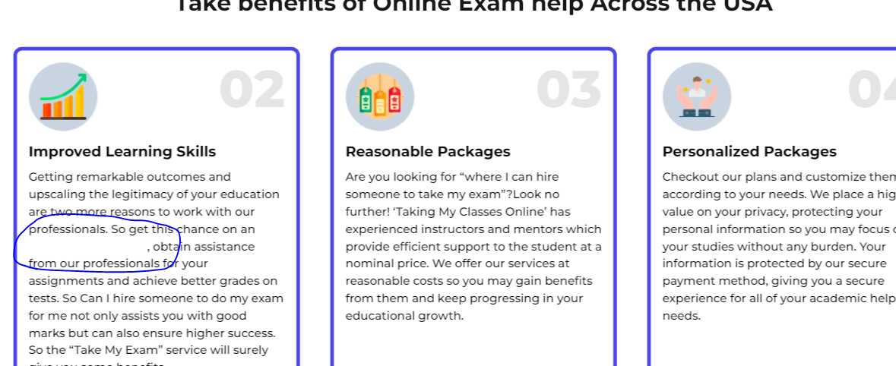

Note: Internal link not visible.

# 2: Still not interlinking



Note: still keywords not interlinked

# 3: Remove the bold text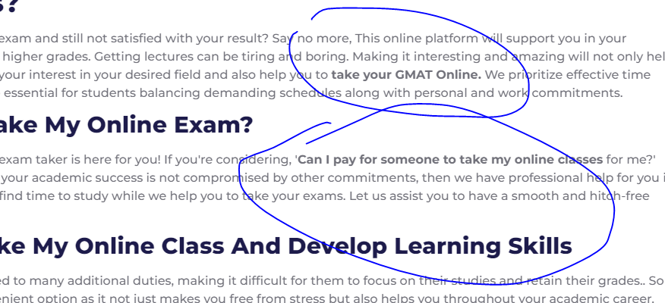

Note: remove the bold tag on interlinking text.

# 4: Active first faq’s accordion.

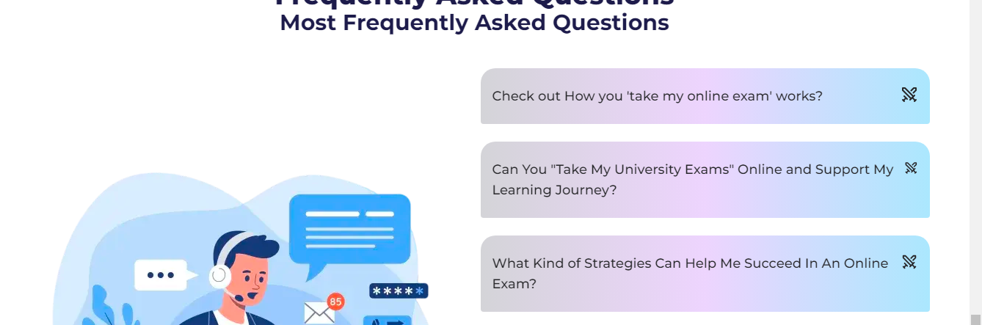

Note: open first question of faq’s